**MAP-REDUCE:**

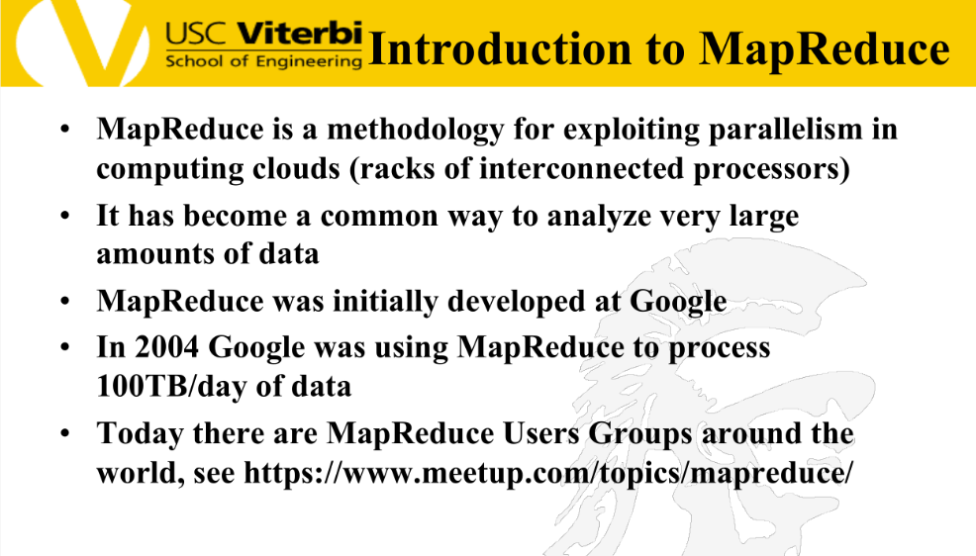

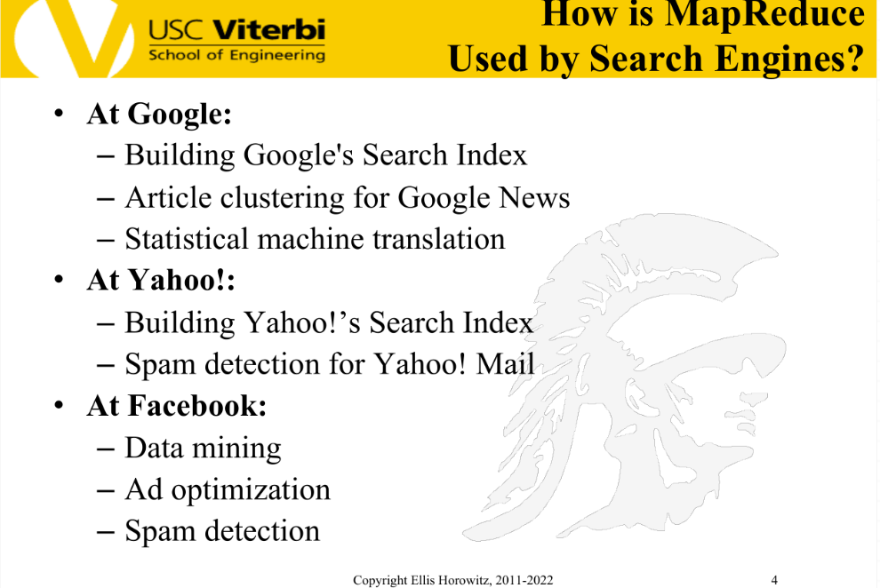

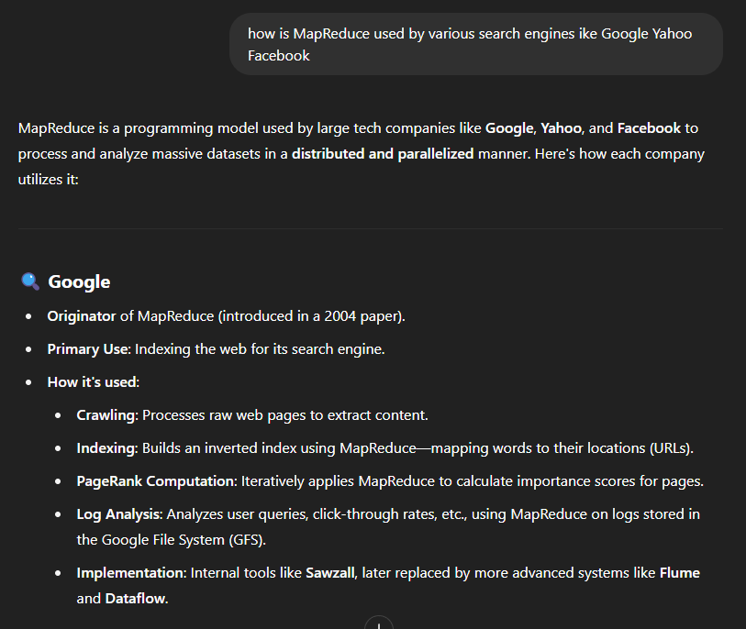

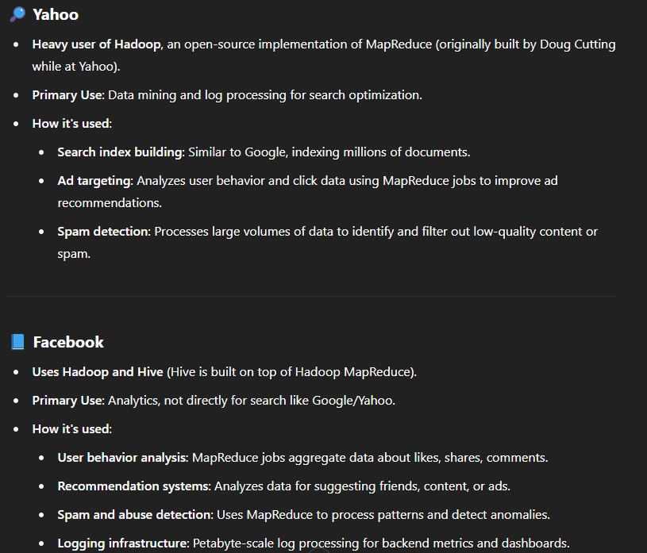

Q. Why is MapReduce suitable for applications like Tesla or Uber data collection?(AND OTHERS) OR

Q. Use of MapReduce in various fields.

A.

**Amazon tracking every user interaction on its website**  
– Every click, search, view, or add-to-cart action is logged.  
– This data is processed in parallel to improve recommendations, inventory planning, and A/B testing.

**Netflix monitoring every viewing behavior**  
– Netflix collects data on pause, rewind, watch time, and completion rate per user.  
– MapReduce-like pipelines analyze this data to optimize content suggestions and plan new productions.

**Uber logging every ride and GPS signal**  
– GPS coordinates, trip durations, surge pricing data, and driver behavior are continuously tracked.  
– Data is processed to optimize routes, predict demand, and reduce ETA estimates.

**Smart home systems like Google Nest collecting sensor data**  
– Temperature changes, motion sensor triggers, door locks/unlocks are logged in real time.  
– This helps run energy optimization models and improve device behavior across millions of homes.

**Dish network collecting every click of the remote**  
– Dish network supplies TV reception via satellite; they collect data on their set-top box and send it back to headquarters.

**Tesla collecting every usage of the car**  
– Teslas are connected to the cellular network; the car reports back all of its actions to Tesla.

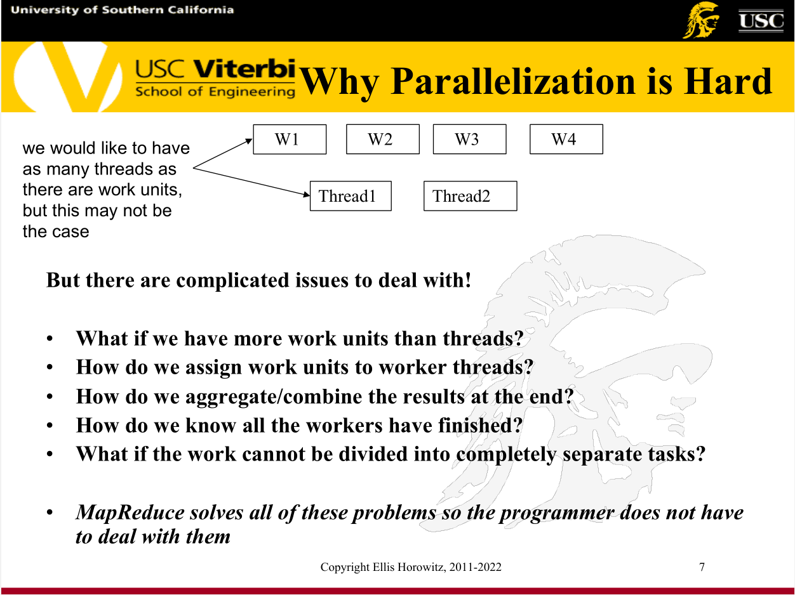

**Why Parallelization is Hard**

Even though we would like to have one thread per work unit (like W1, W2, W3, W4), this is often not the case in practice. Parallelizing tasks across threads introduces several challenges:

**1. What if we have more work units than threads?**  
We need to schedule and distribute work units efficiently among fewer threads.

**2. How do we assign work units to worker threads?**  
Assigning tasks optimally is difficult. Poor distribution can lead to imbalance or idle threads.

**3. How do we aggregate or combine the results at the end?**  
When all threads finish, we must combine their outputs correctly. This requires coordination.

**4. How do we know all the workers have finished?**  
Synchronizing the completion of all threads without causing errors is complex.

**5. What if the work cannot be divided into completely separate tasks?**  
Some tasks depend on shared data or results, making parallelization harder.

**MapReduce solves all of these problems so the programmer does not have to deal with them.**  
It abstracts away thread management, synchronization, and result merging, letting the developer focus only on the core logic of the map and reduce functions.

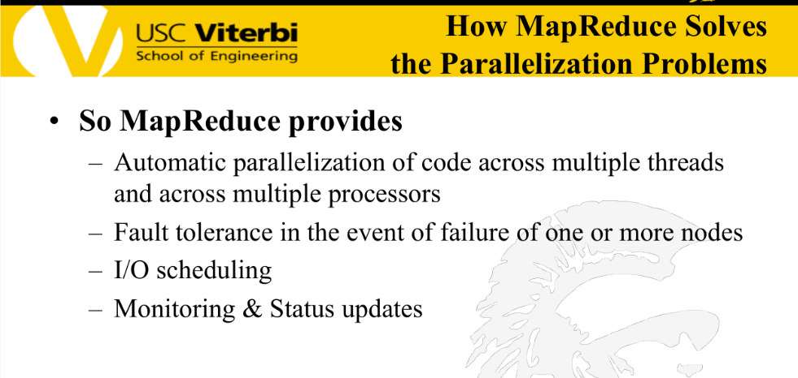

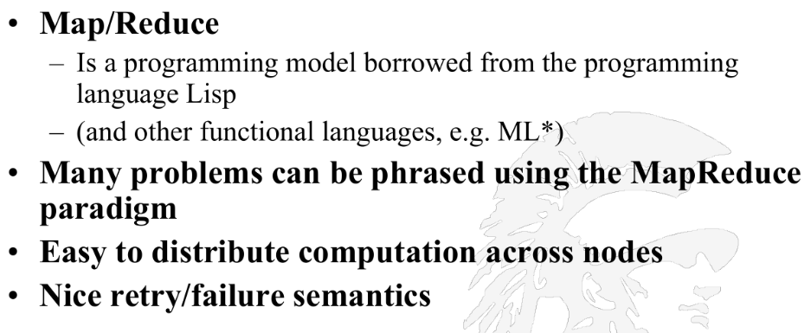

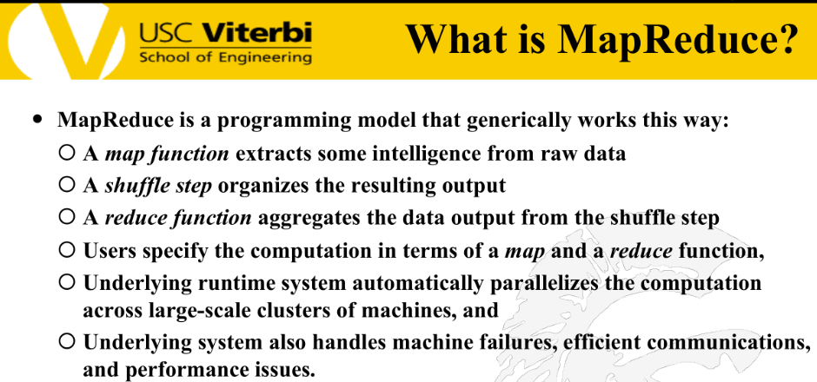

Lambda function is also called anonymous function.

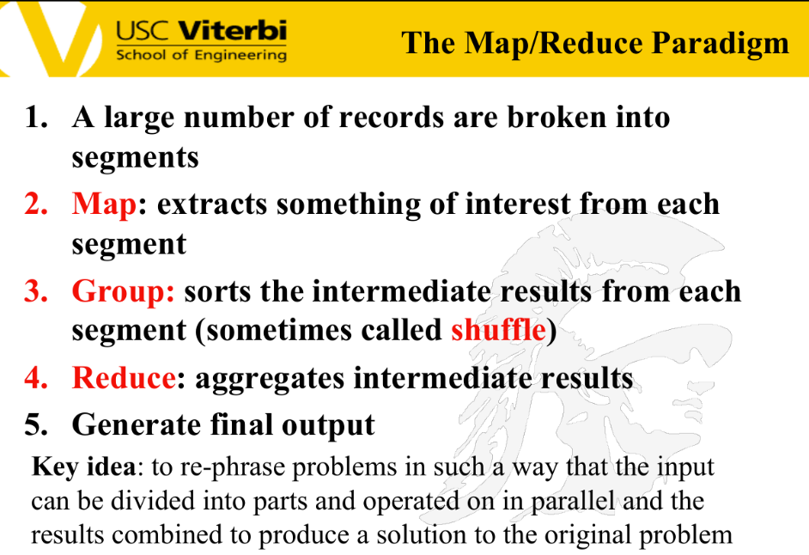

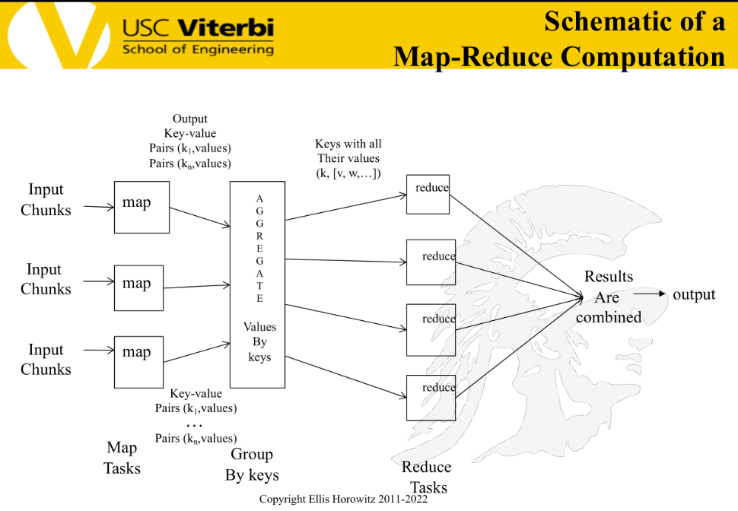

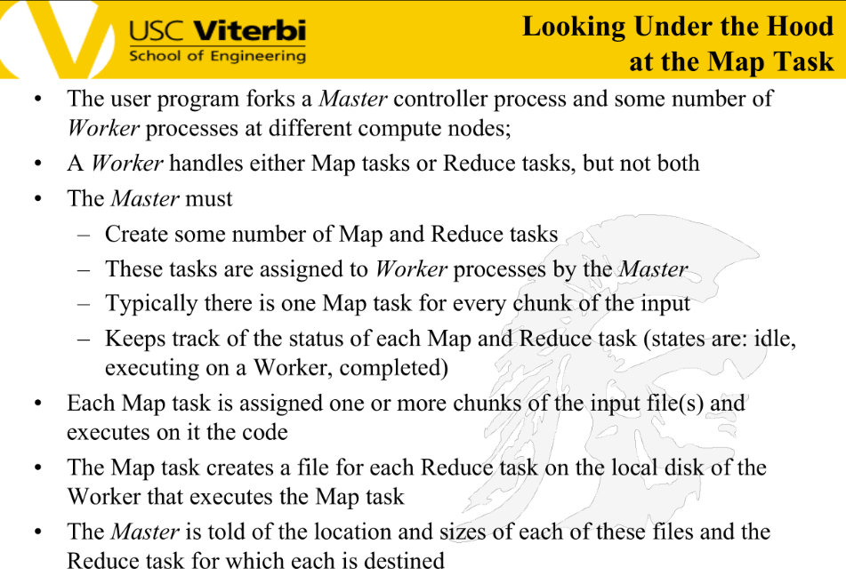

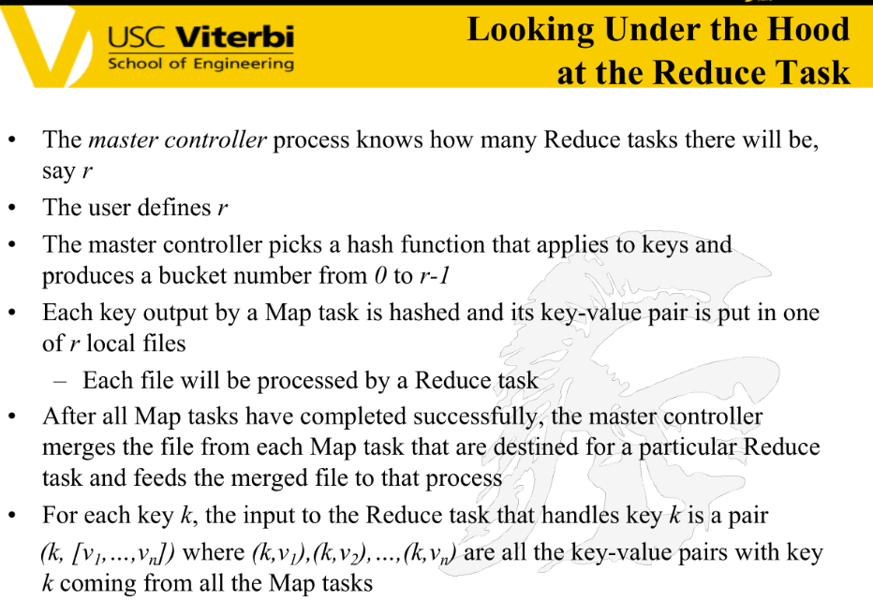

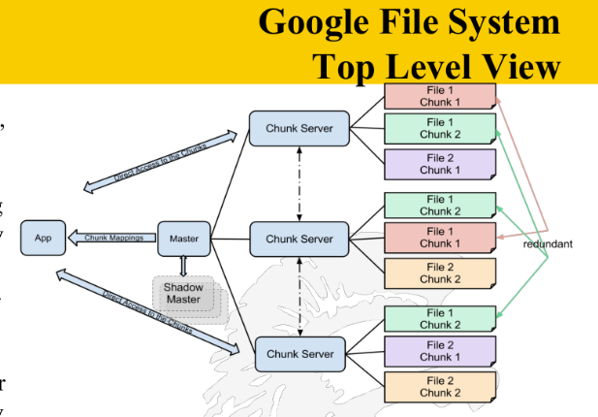

**SEARCH ENGINE ADVERTISING**

Q. What might be new forms of search engine advertising now that AI will make the ones that we have now redundant?

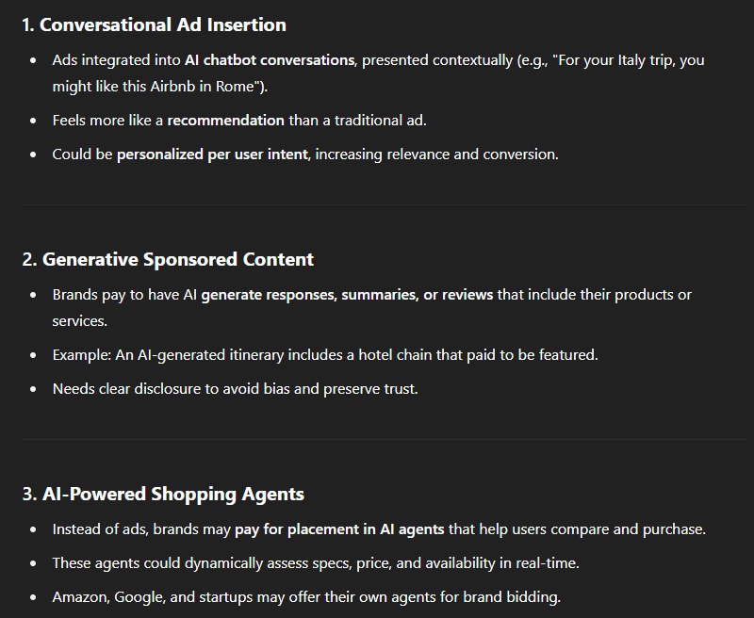

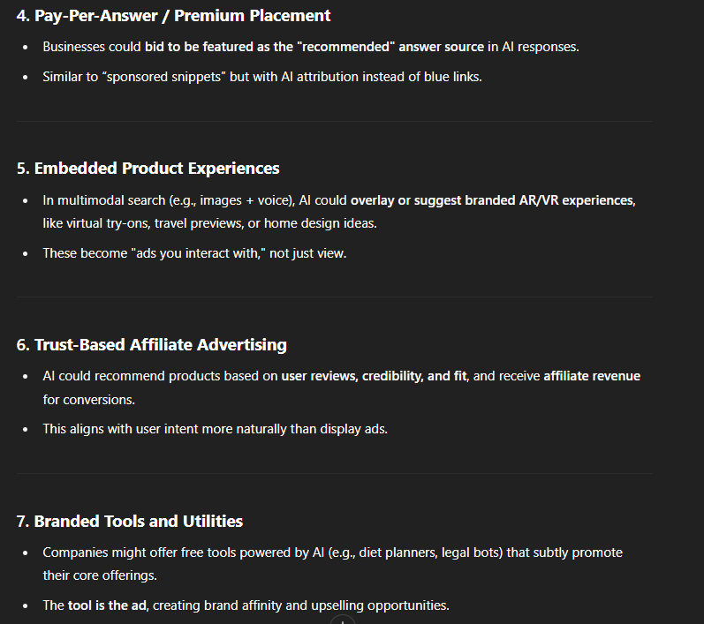

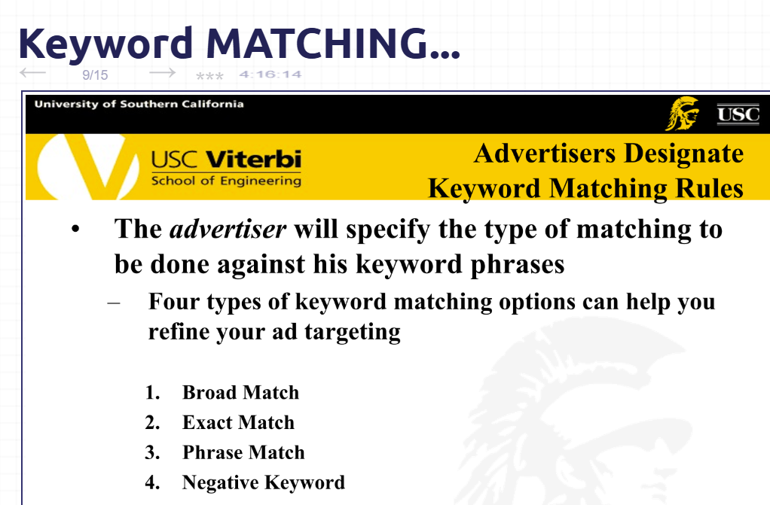

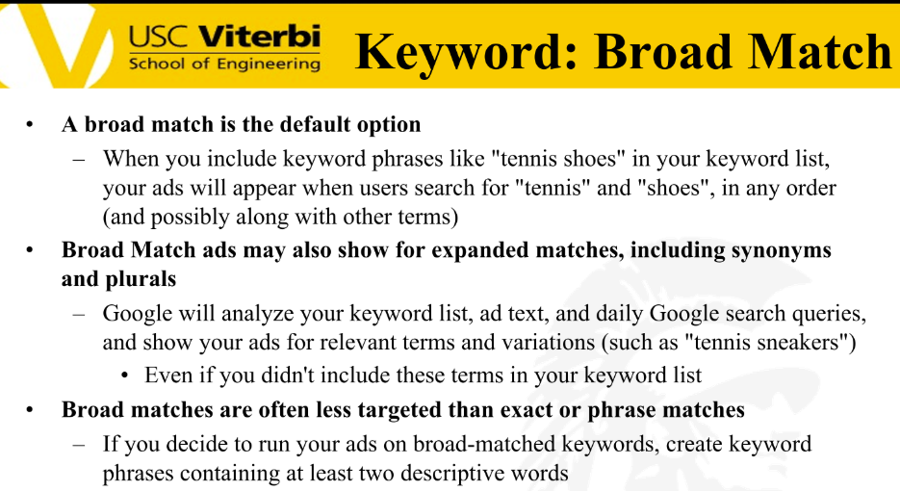

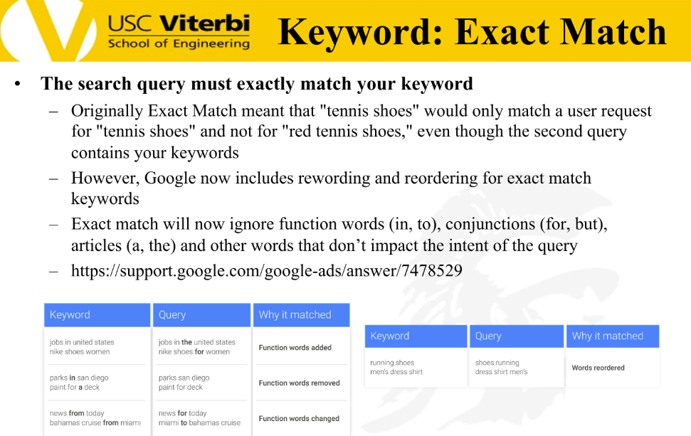

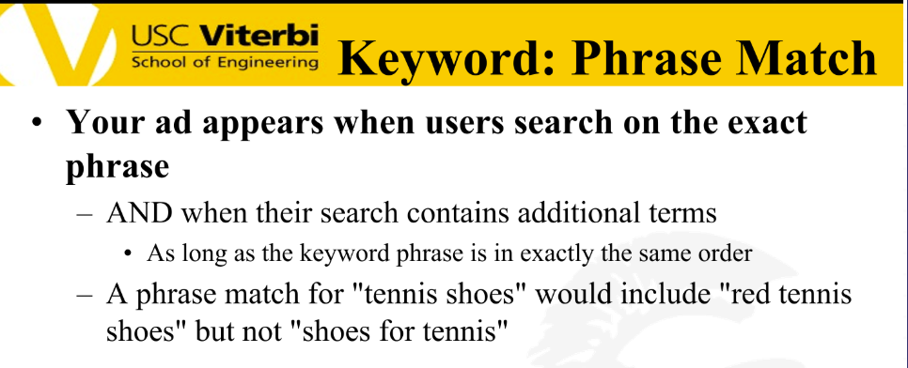

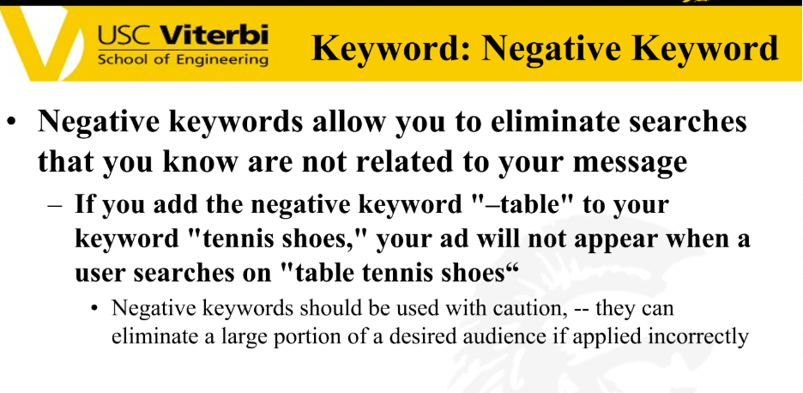

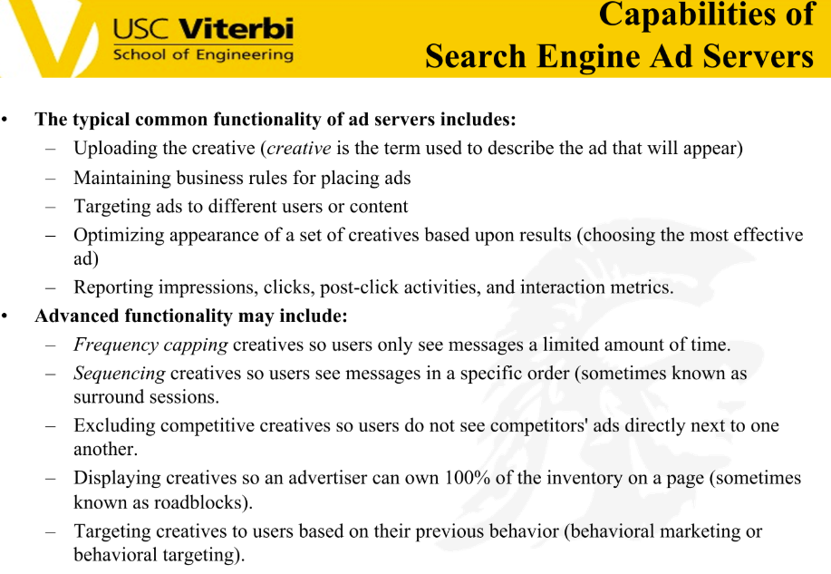



**KNOWLEDGE GRAPH**

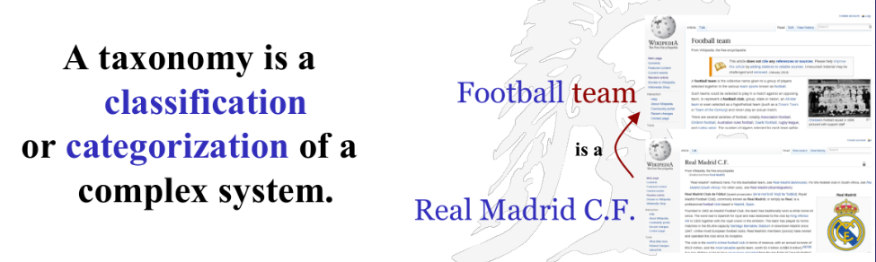

A **taxonomy** is a structured representation of concepts in a tree-like hierarchy, where **broad categories** are subdivided into **narrower, more specific topics**. It helps IR systems understand relationships between terms and improve query matching.



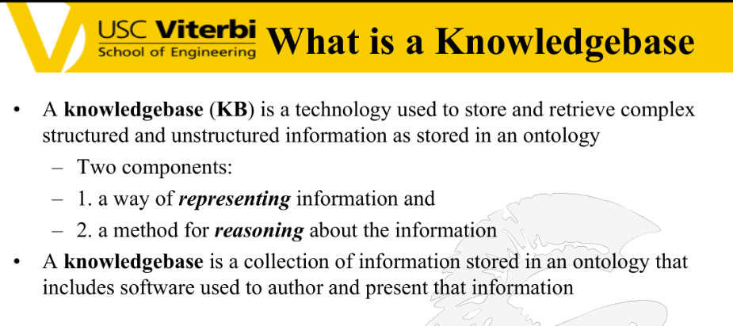

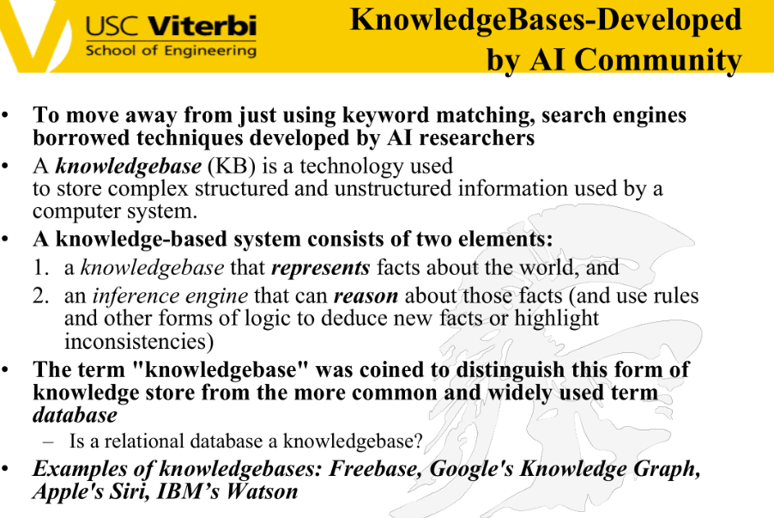

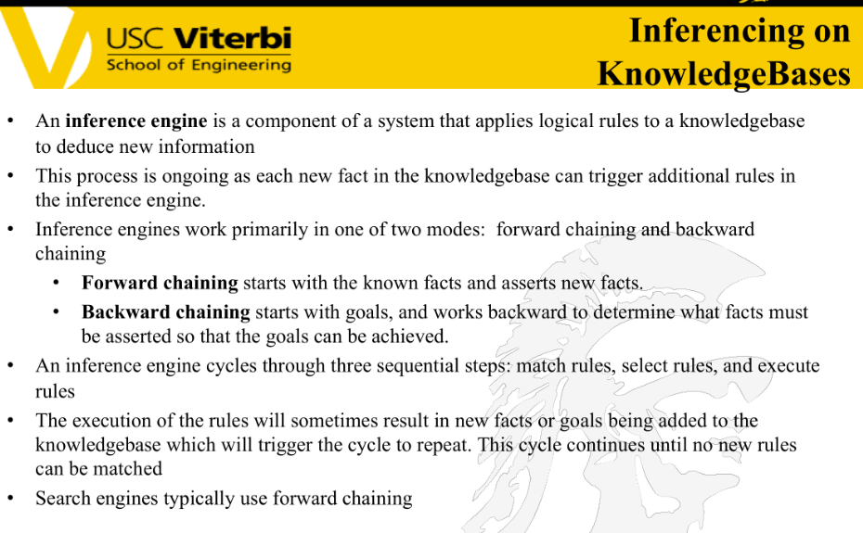

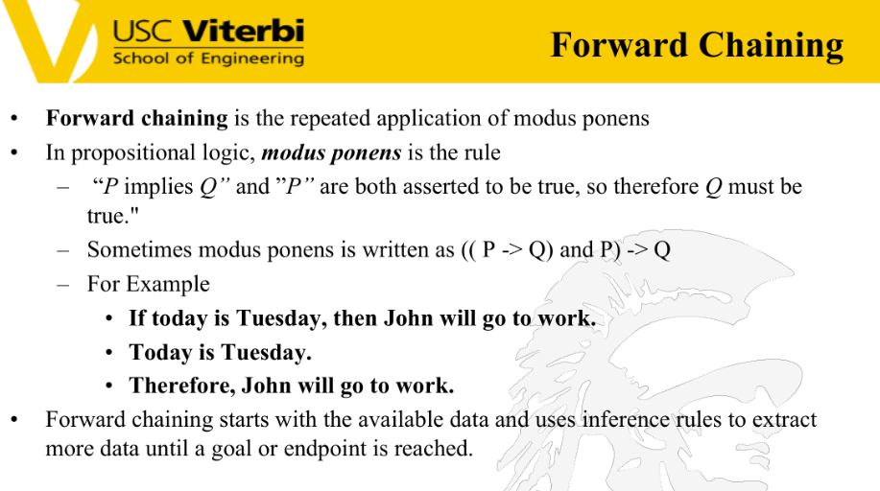

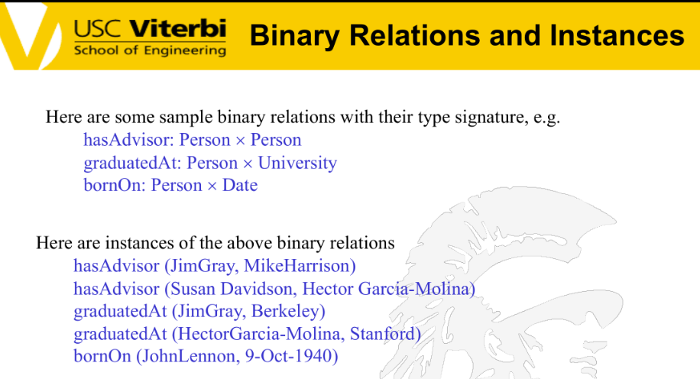

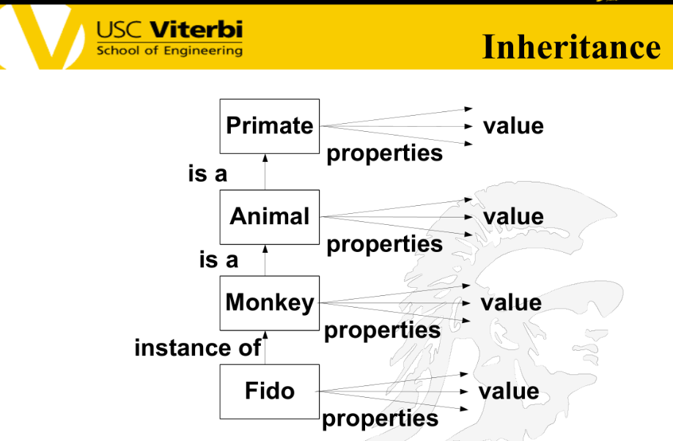

**Some Advantages of Inheritance**

* Inheritance provides a natural mechanism for *representing taxonomically structured knowledge*
* Inheritance provides an economical means of *expressing properties common to a class of objects/concepts*
* Inheritance *guarantees that all members of a class inherit the appropriate properties* thus ensuring consistency with the class definition
* Inheritance *reduces the size of the knowledge base* as properties are defined once for the most general type of object/concepts and these properties are then shared by other less generic objects/concepts in the type hierarchy.

**CAN COME IN EXAM -- TABLE**

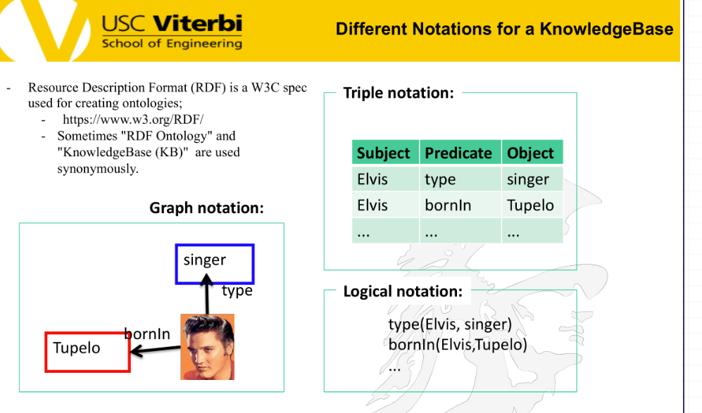

Q. How would you represent this using XML, JSON and csv?

A.

**XML:**  
<KnowledgeBase>

<Entity>

<Subject>Elvis</Subject>

<Predicate>type</Predicate>

<Object>singer</Object>

</Entity>

<Entity>

<Subject>Elvis</Subject>

<Predicate>bornIn</Predicate>

<Object>Tupelo</Object>

</Entity>

</KnowledgeBase>

**JSON:**  
{

"KnowledgeBase": [

{

"subject": "Elvis",

"predicate": "type",

"object": "singer"

},

{

"subject": "Elvis",

"predicate": "bornIn",

"object": "Tupelo"

}

]

}

**CSV:**  
Subject,Predicate,Object

Elvis,type,singer

Elvis,bornIn,Tupelo

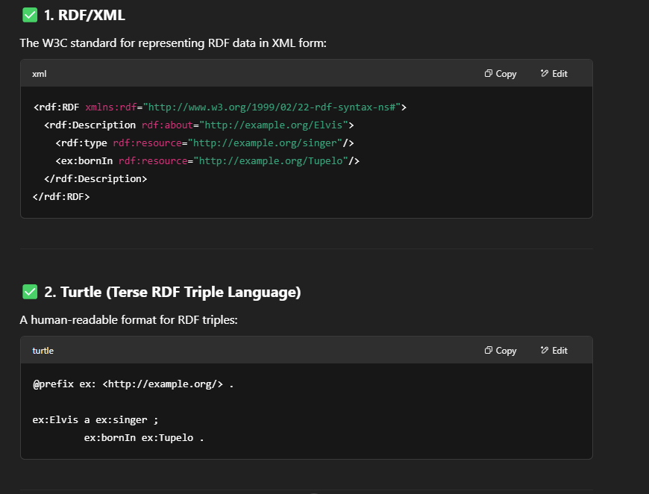

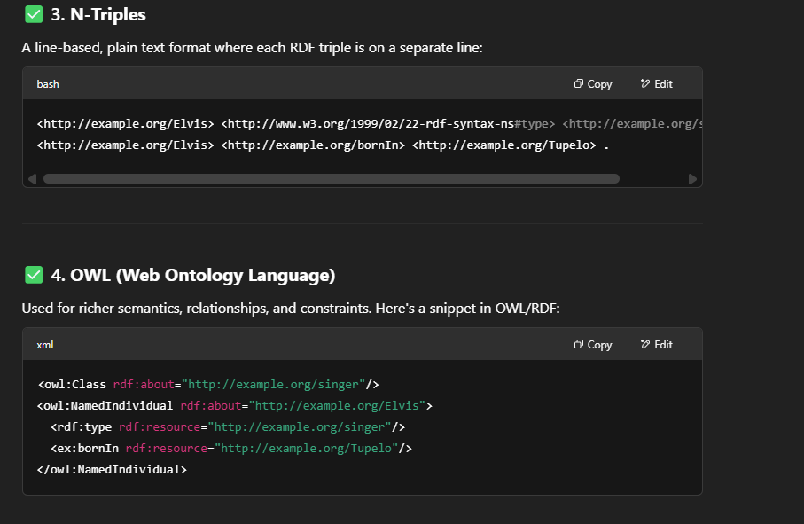

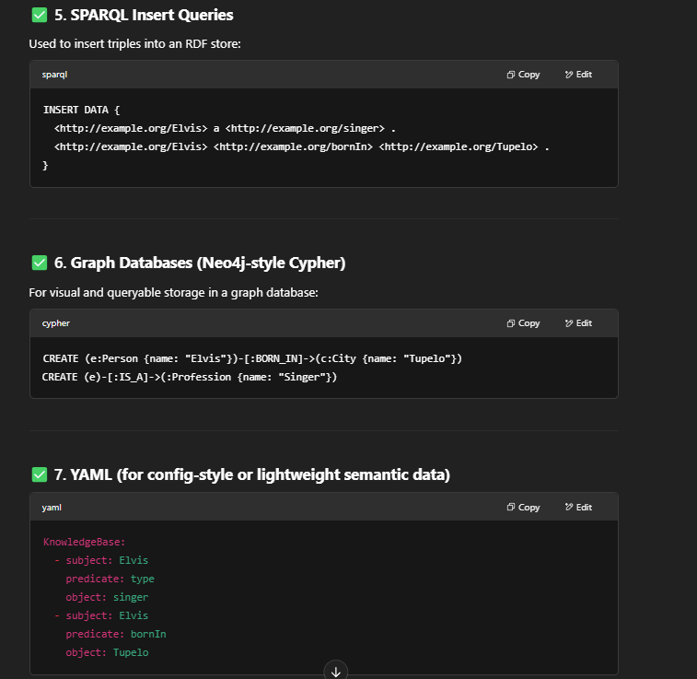

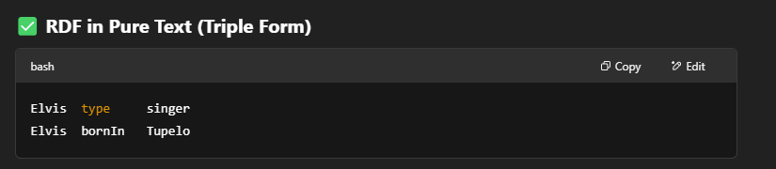

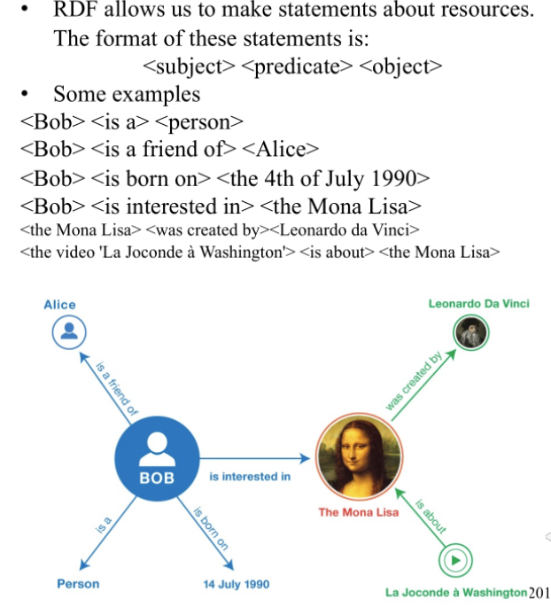

**PAGERANK**

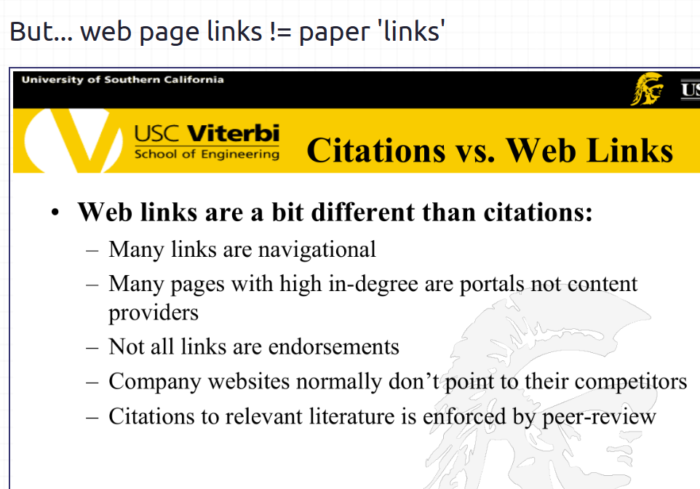

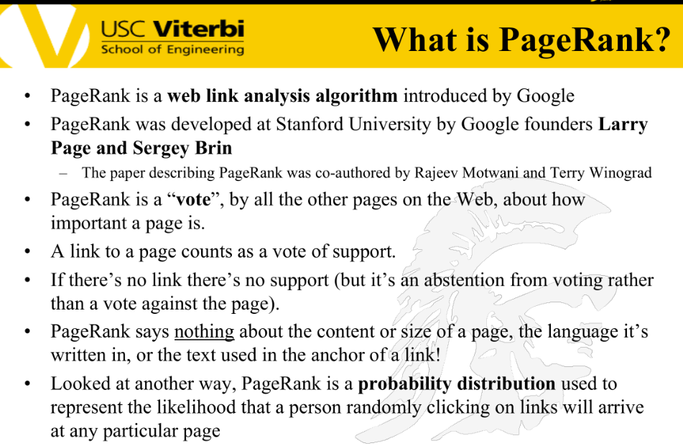

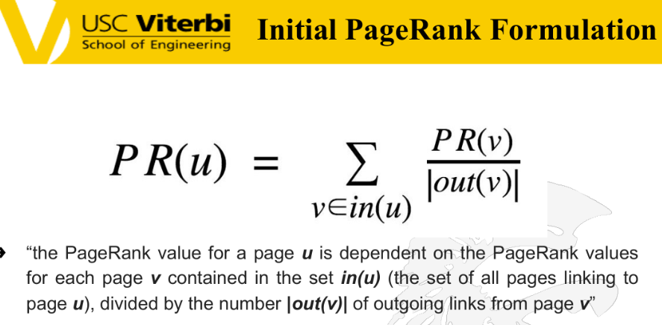

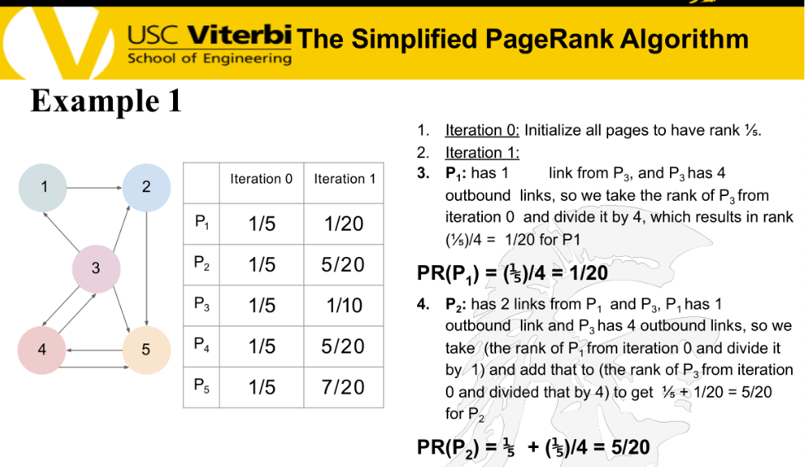

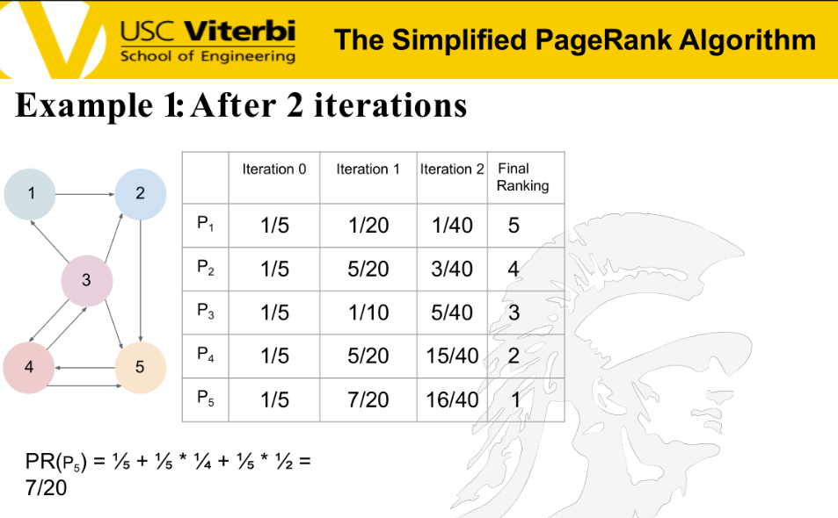

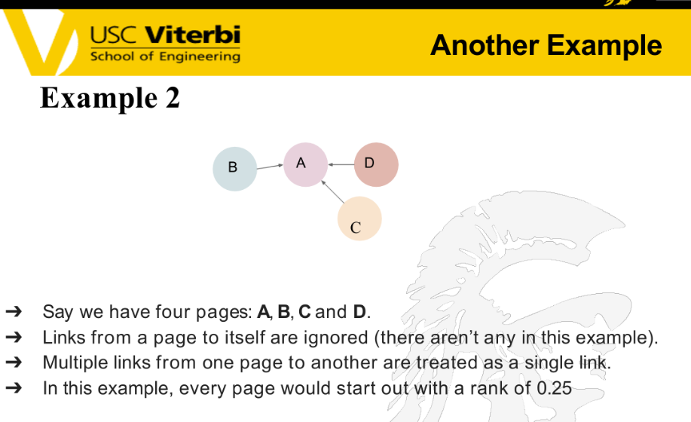

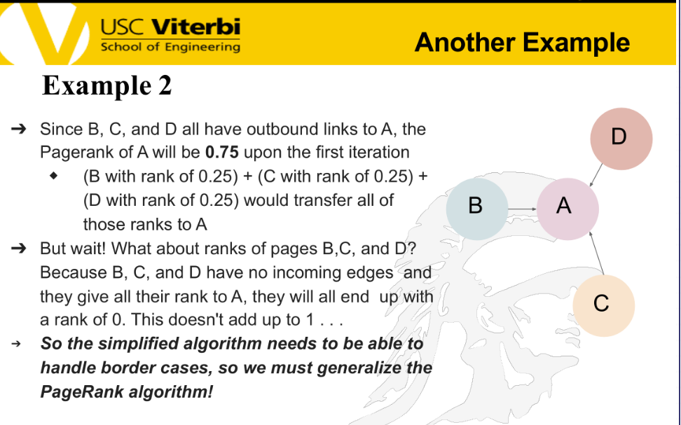

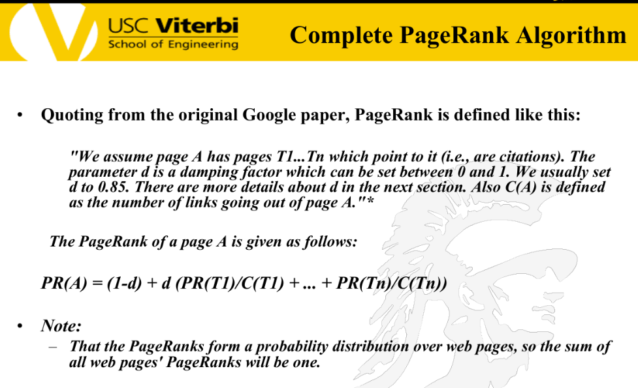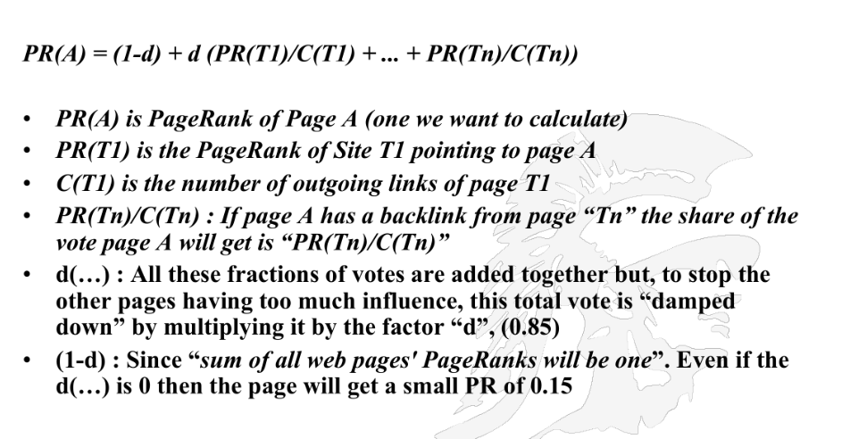

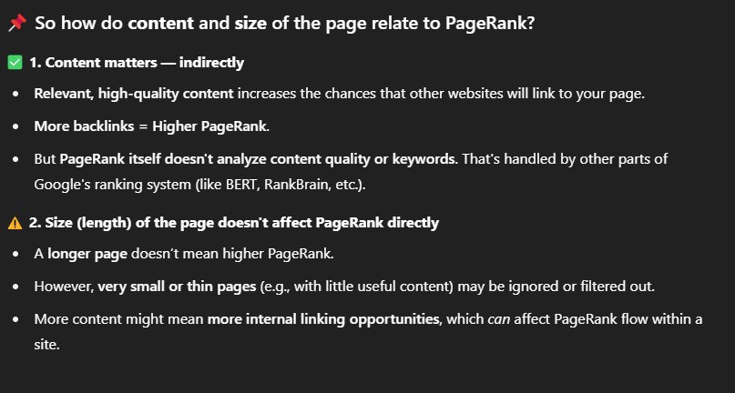

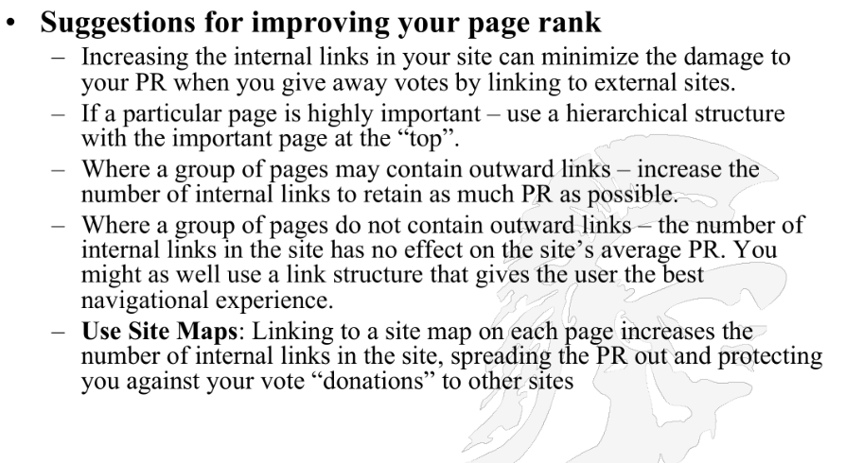

**SNIPPETS**

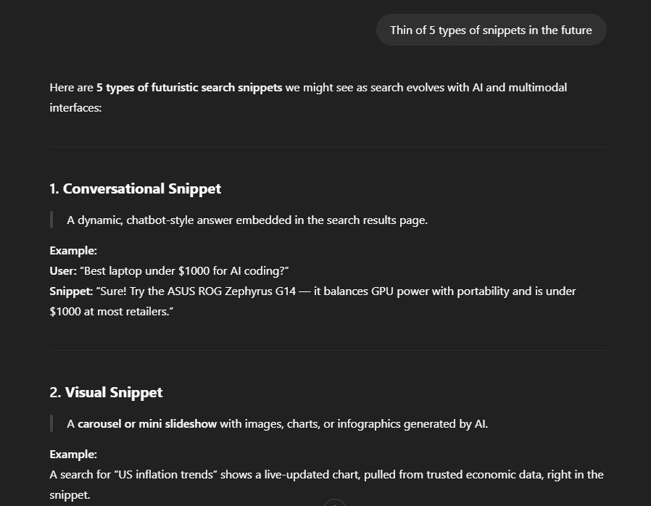

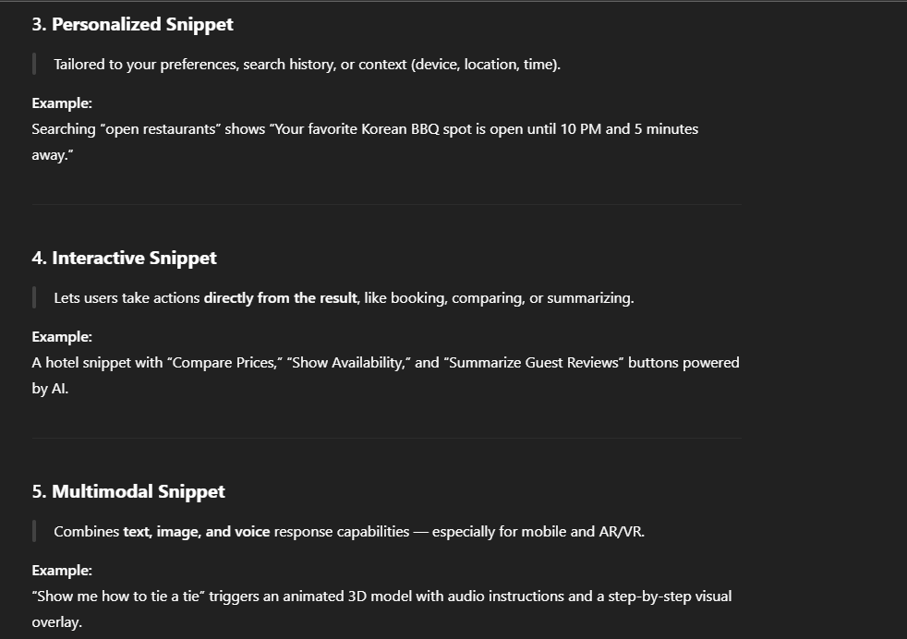

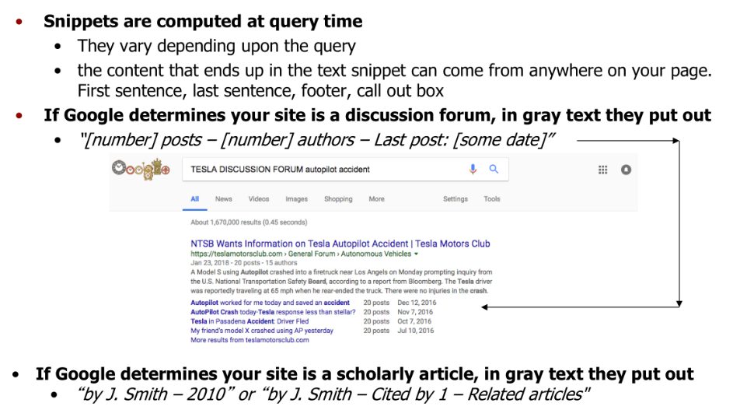

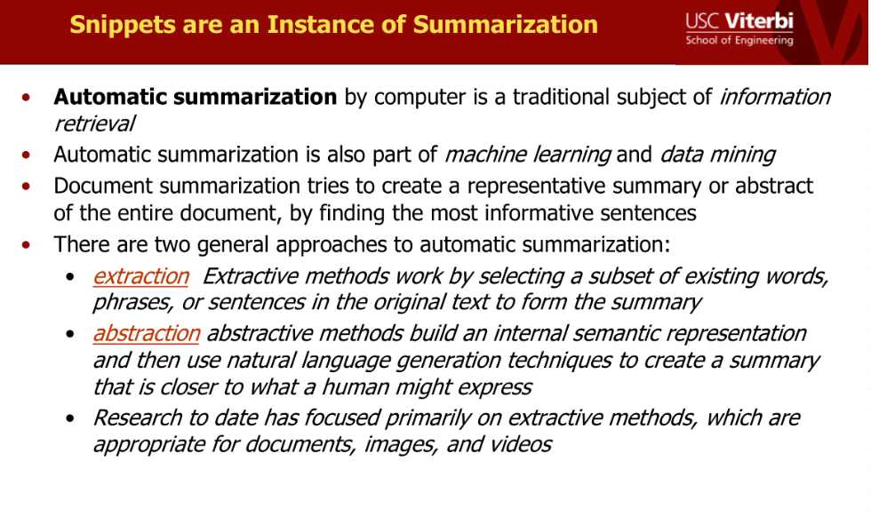

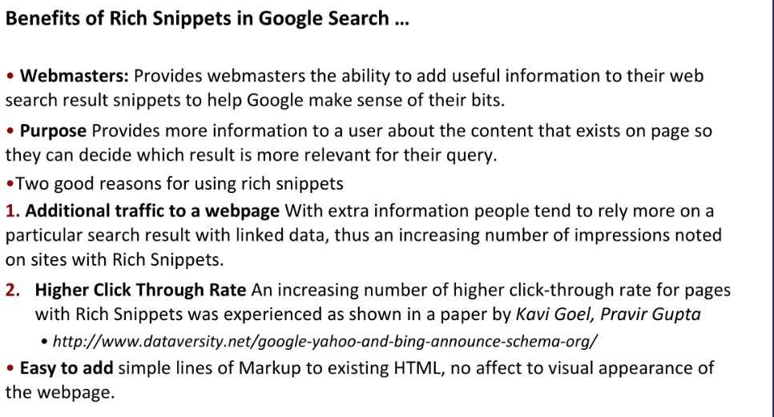

**AUTOCORRECT/AUTOCOMPLETION**

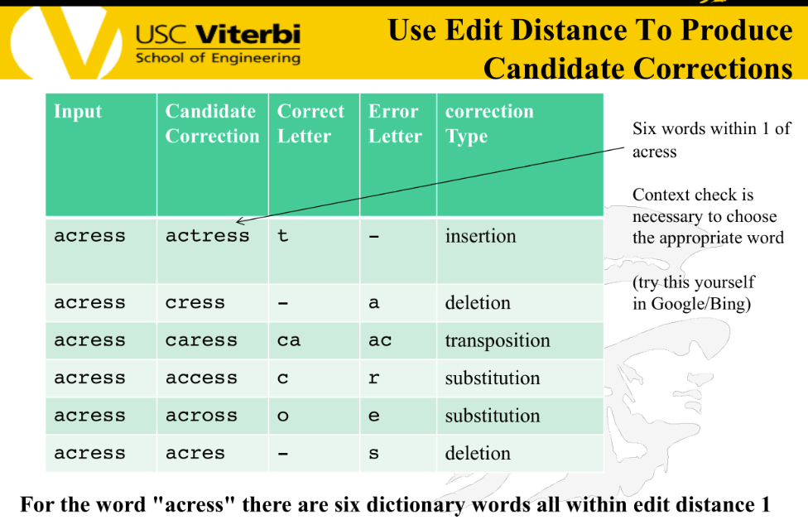

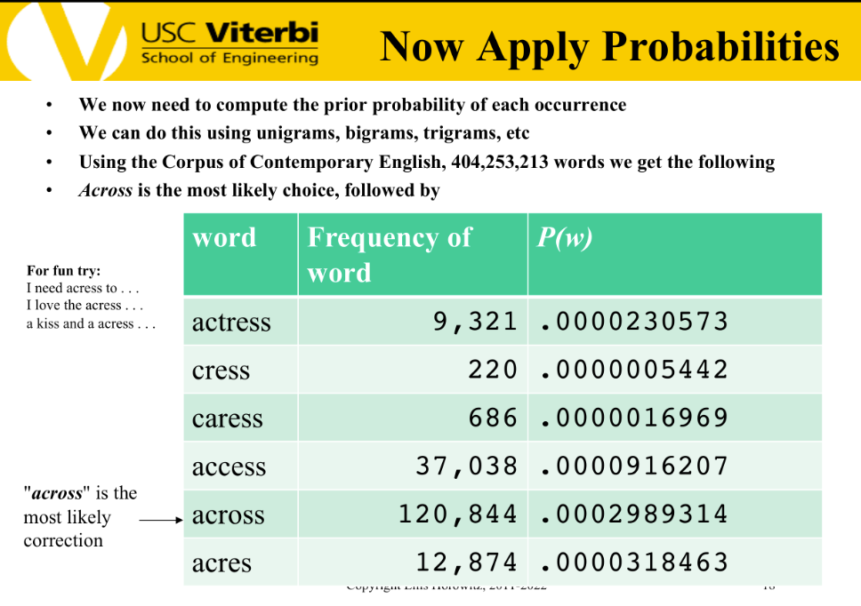

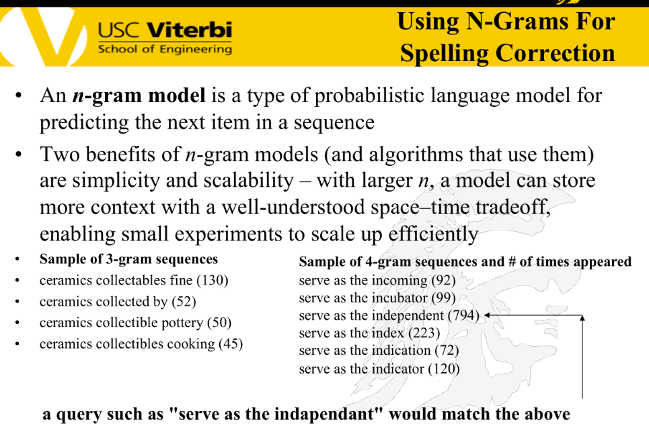

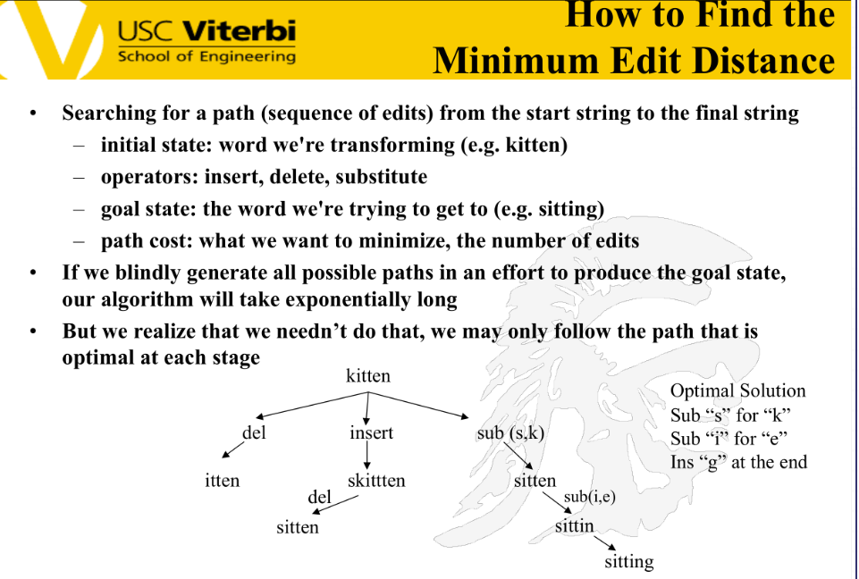

**QUERY PROCESSING**

Following slides contain heuristics that can be applied to speed up the process

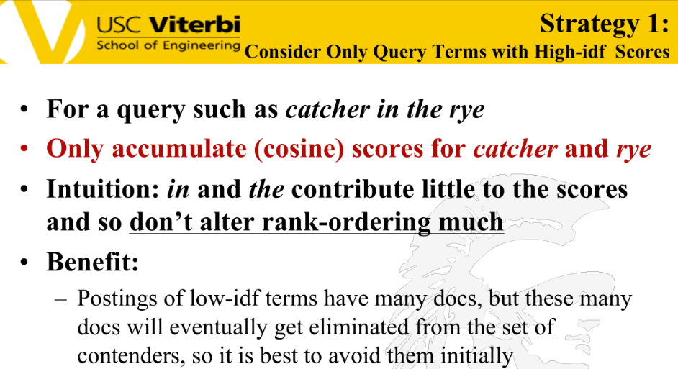

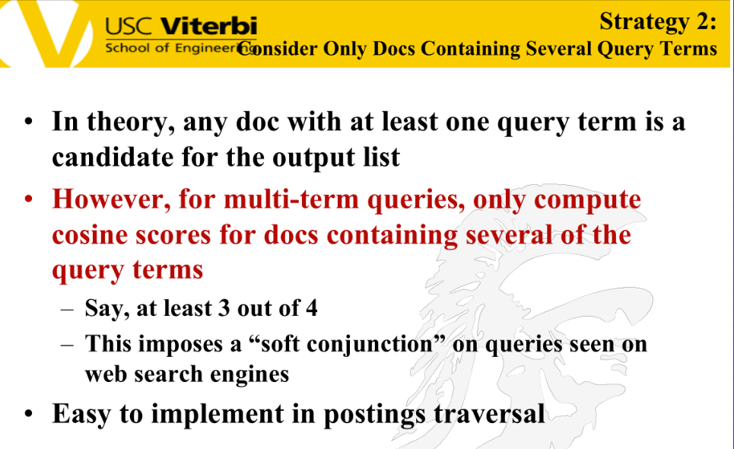

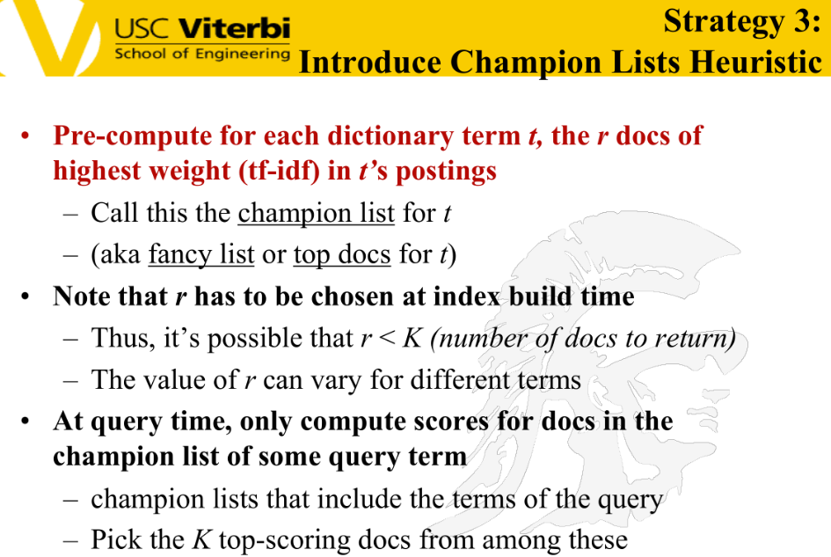



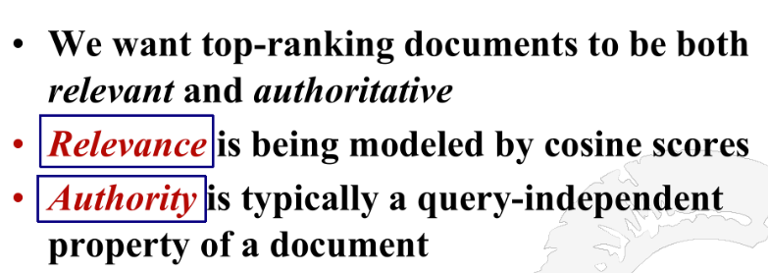

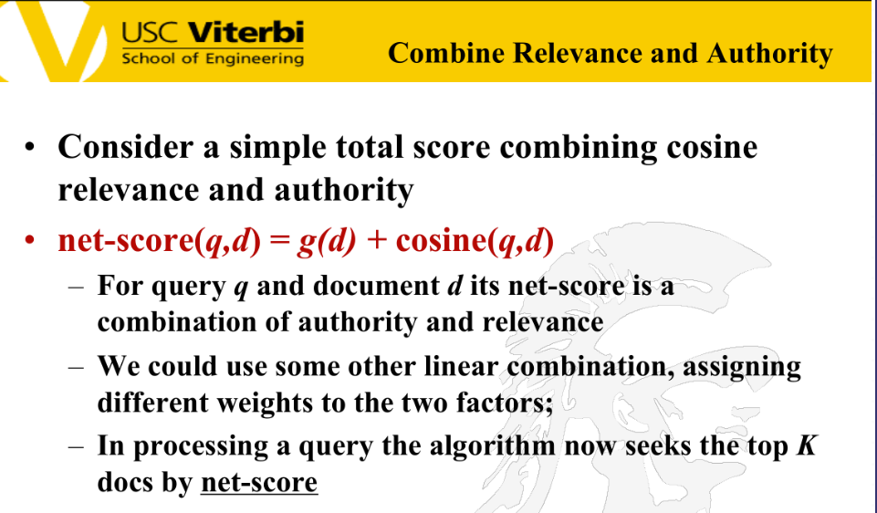

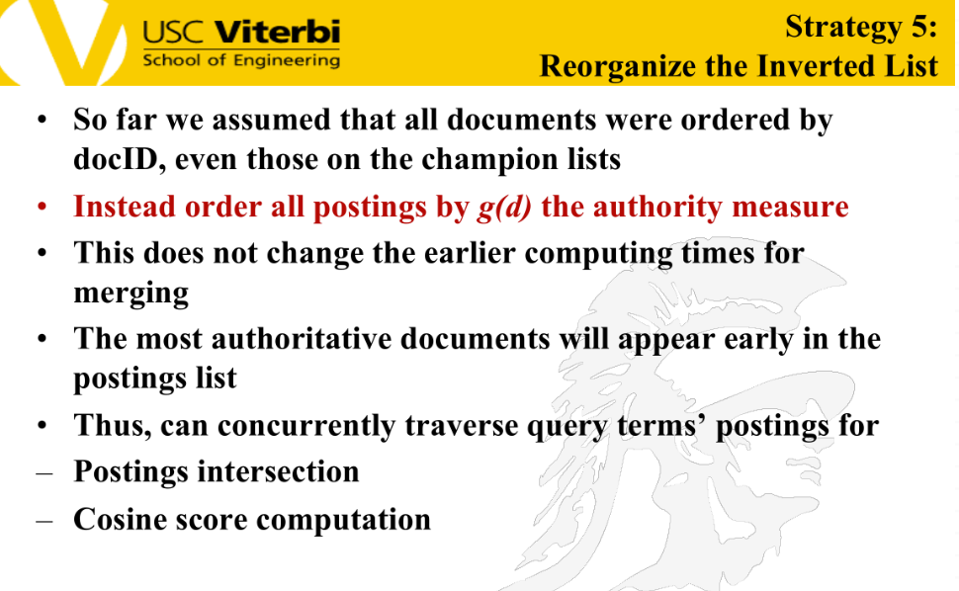

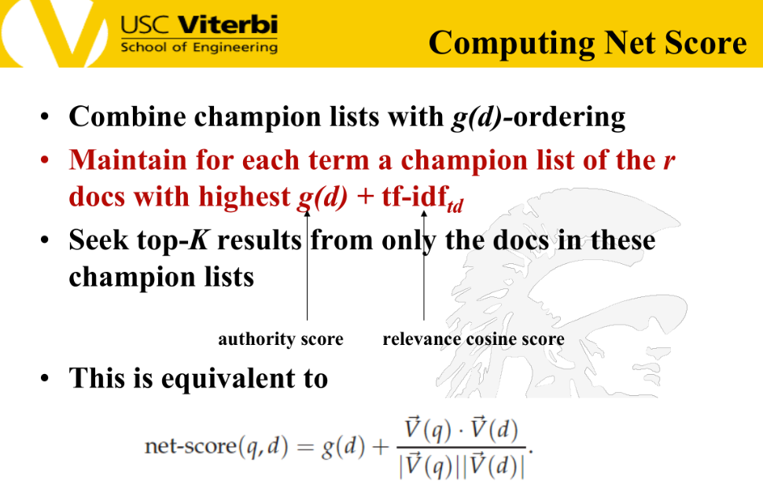

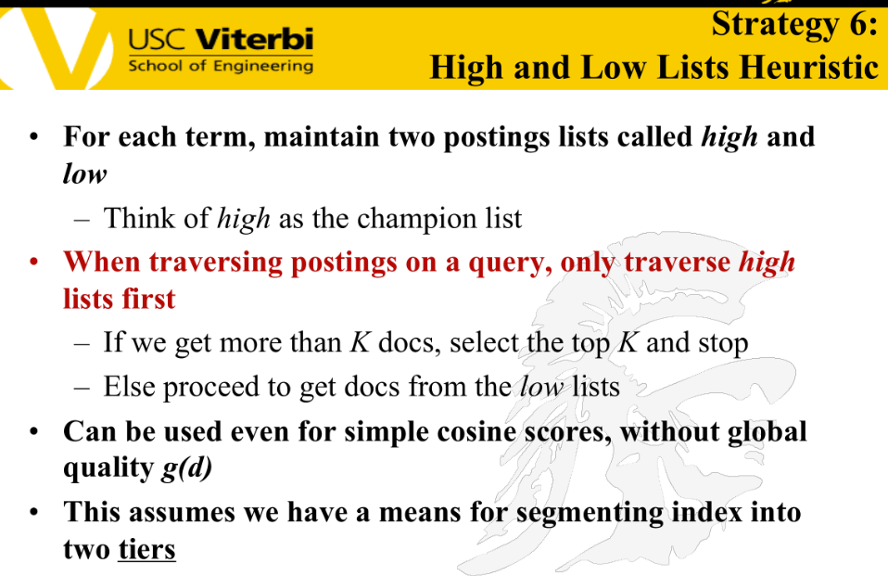

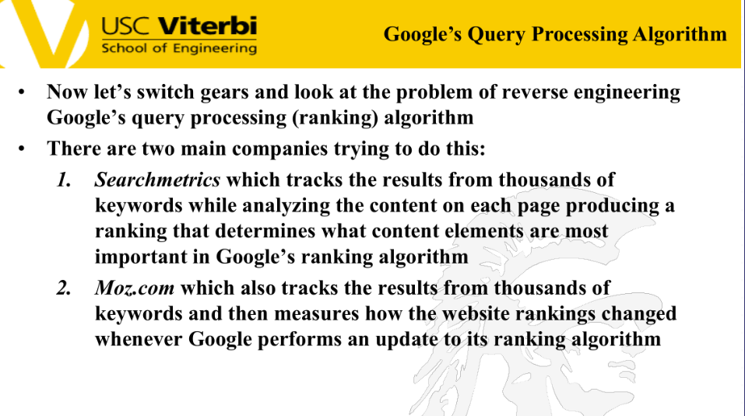

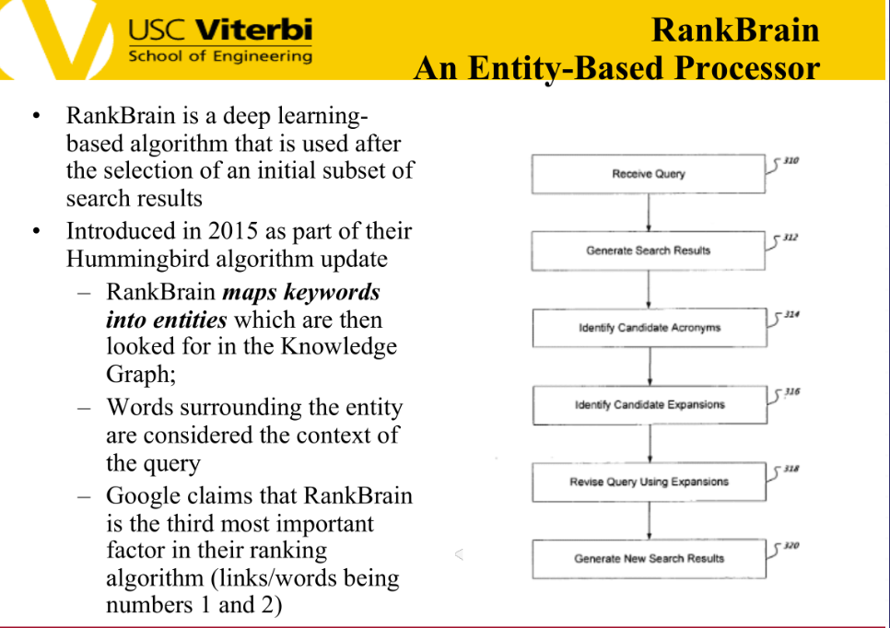

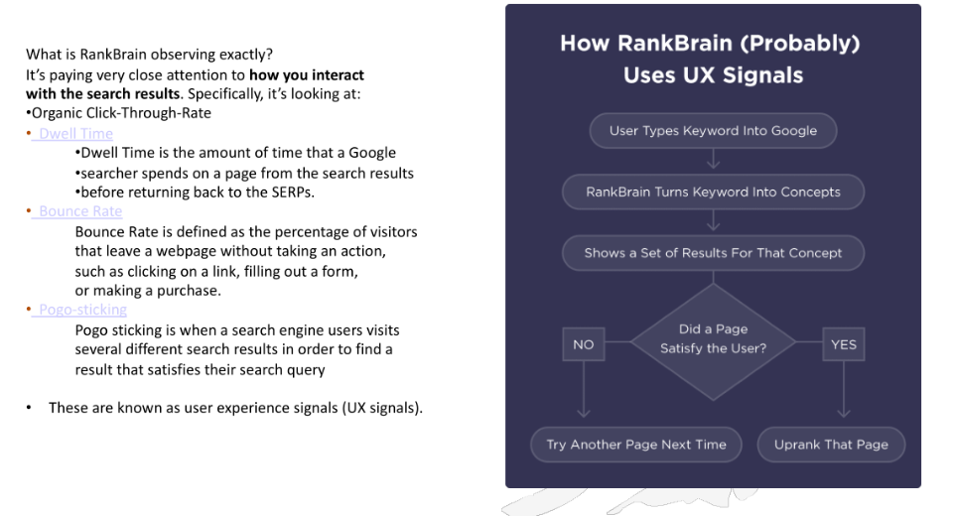

**QUESTION-ANSWERING**

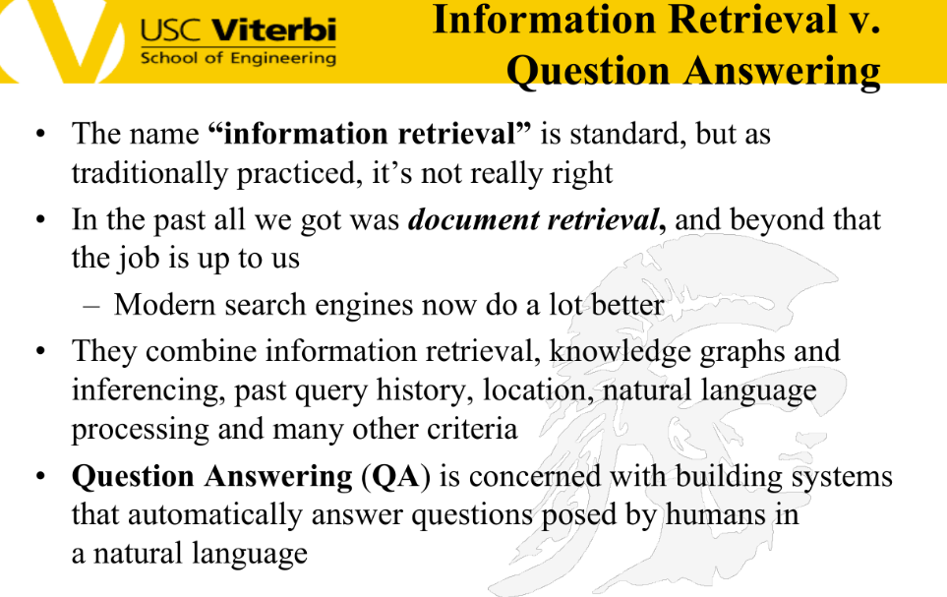

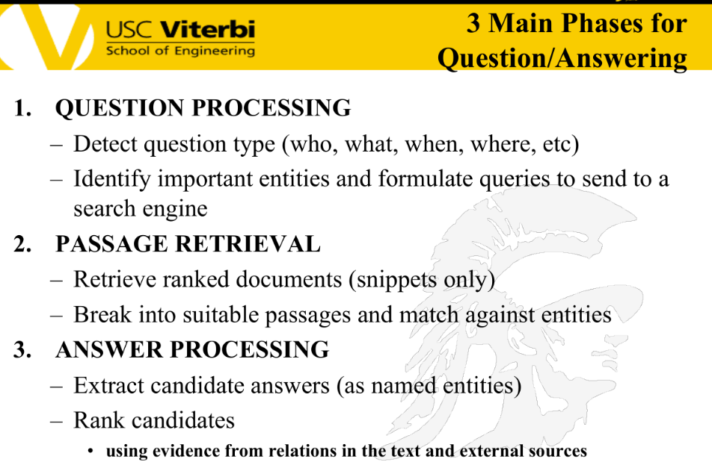

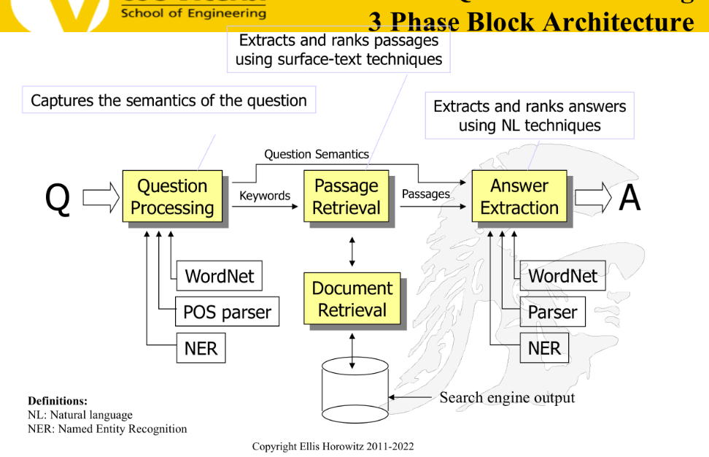

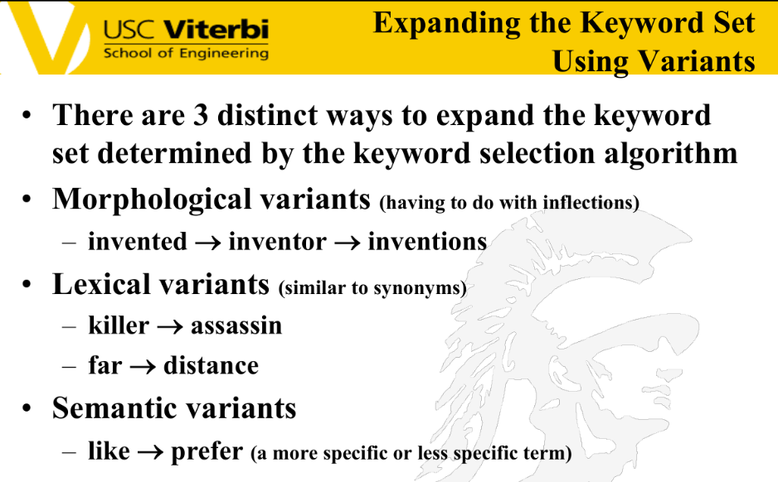

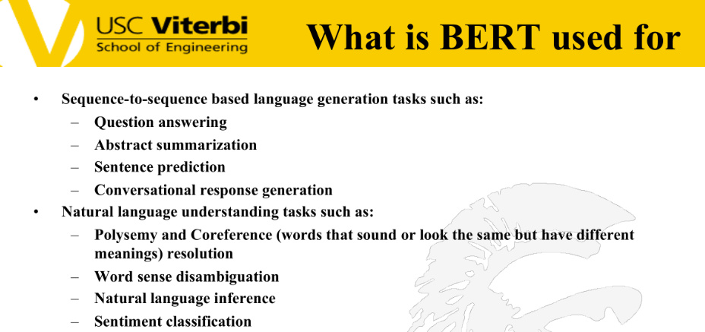

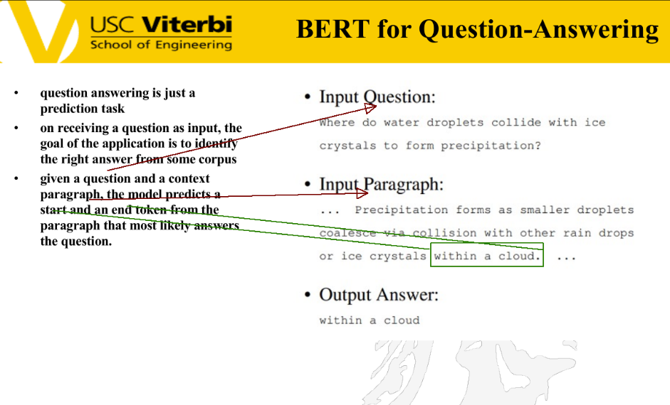

**RECOMMENDATION SYSTEM**

